**Stoll MTP**

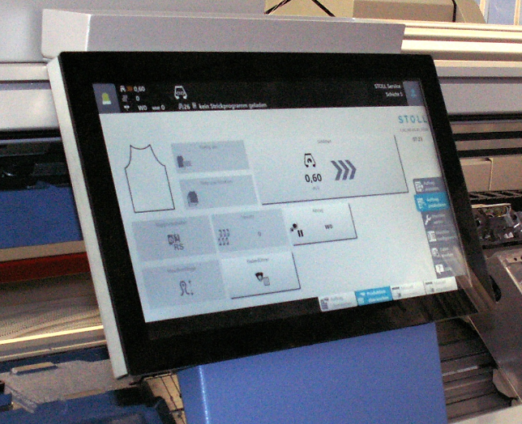

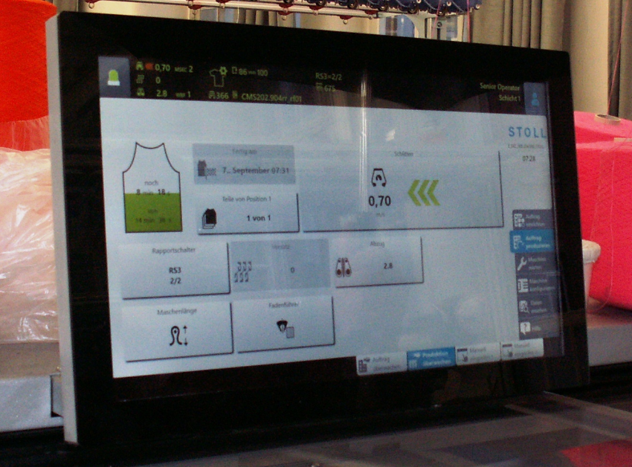

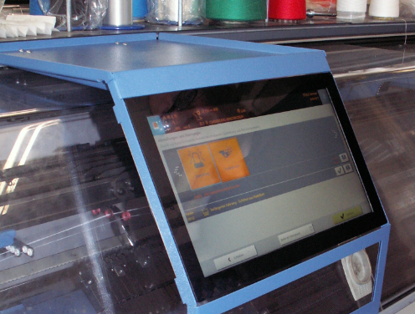

|  |
| --- |
| **Display** |
| Display size | 15.6' |
| Touchscreen | Cap. touch |
| Resolution | 1366*768 |
| Aspect Ratio | 16:9 |
| White luminance（cd/㎡） | 400 |
| Contrast Ratio | 1000 |
| Backlight lifetime（hrs） | 70000hrs |
| Backlight type | LED |
| Colors | 16.7M colors |
| Response Time(ms) | 35 ms |
| Viewing angle (°) for CR>=10 | 85°85°85°85° |
| **Controller** |
| CPU | Intel Atom x5 E3930 |
| RAM | 2GB DDR4 |
| SSD | 32G |
| Operating system | Windows 10 IoT Enterprise LTSB 2016 1607 64bit |
| USB | 2*USB 3.0 Type A |
| Ethernet ports | 2*1000 base Tx |
| **General** |
| Outline Dimensions | 392.2*241.5*48mm |
| Input supply voltage | 12V DC |
| Input Current max | 3.5A 12VDC |
| Power consumption type | 18W |
| Operating Temp | +15° to… +45° |
| Storage Temp | -15° to… +60° |
| Power connector | Tyco 1-770969-0 |
| CE conformity | EMC directive |
| safety | EN60950/UL60950 |
| CCC conformity | free of CCC |
|  |  |
| **Mechanic** |  |
| mounting points | 4 xM4 371x220mm |
| 2 x side USB | yes |
| power & Ethernet below | yes |
| vibration  DIN EN 60068-2-6 | o.k |
| shock  DIN EN 60068-2-27 | o.k. |
| weight | 3,25 kg |
| **Electric** |  |
| SUS S5 signal | MTP down |
| backup RTC / goldcap | yes, MC-battery |
| SSD interchangeable | yes |